Level 32 -> Level 33

Once logged in to the level 32, we are welcomed by the message "WELCOME TO THE UPPERCASE SHELL". Now, our goal is to figure out how to use commands in this shell.

Each command that we type is converted into uppercase and hence it did not work. Getting idea from **man sh** I got to know that **$0** can be used to invoke the Bash.

Using **ls -la** we found that user bandit32 has escalated its privileges to bandit33.

Now, the next step is very easy.

We can simply use command **cat /etc/bandit_pass/bandit33** to get the password.

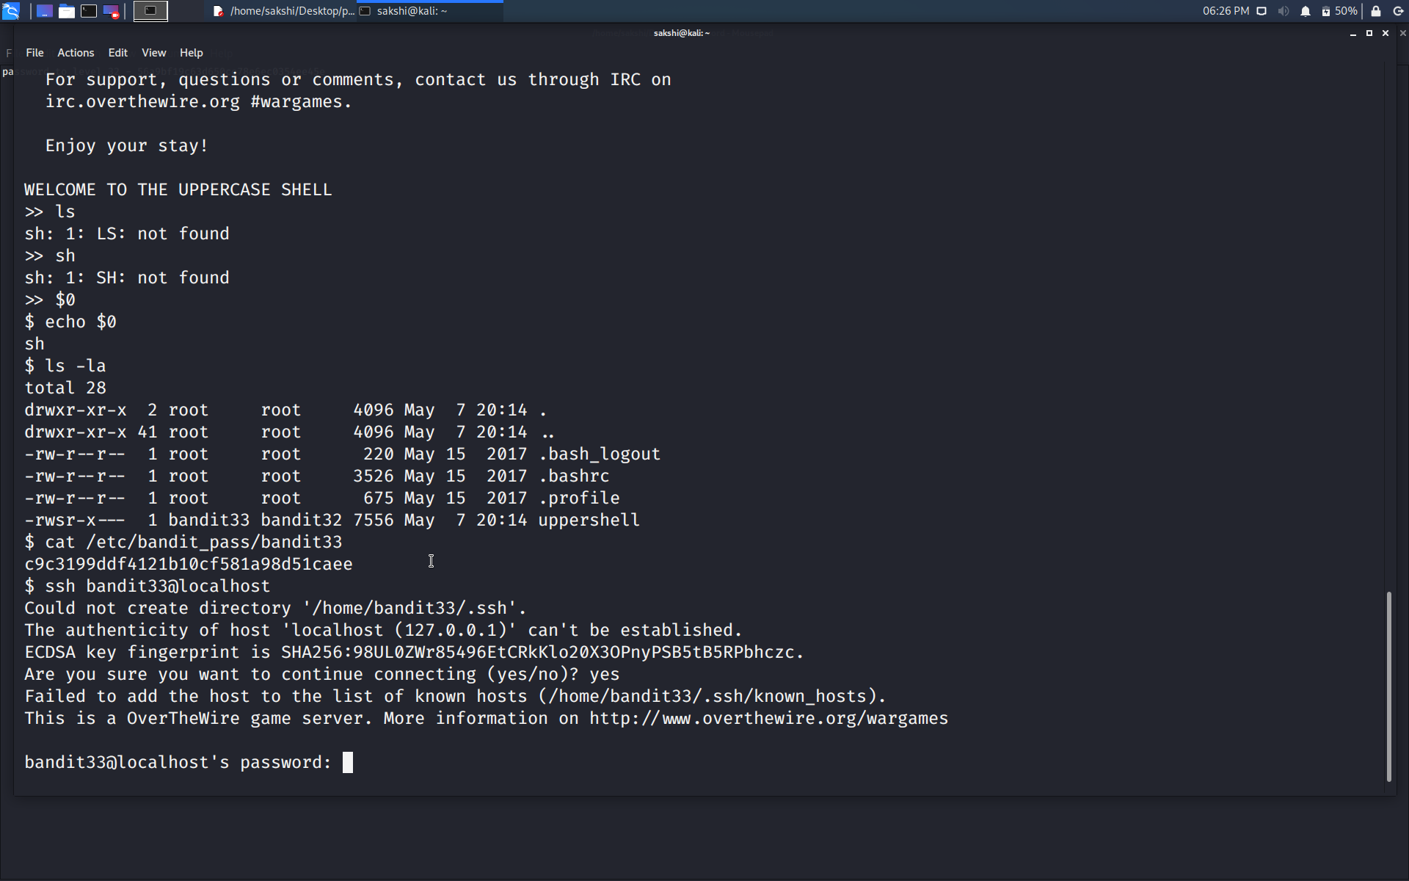

Use the command **ssh bandit33@localhost** to connect to the level 33.

Enter the password and hit enter.

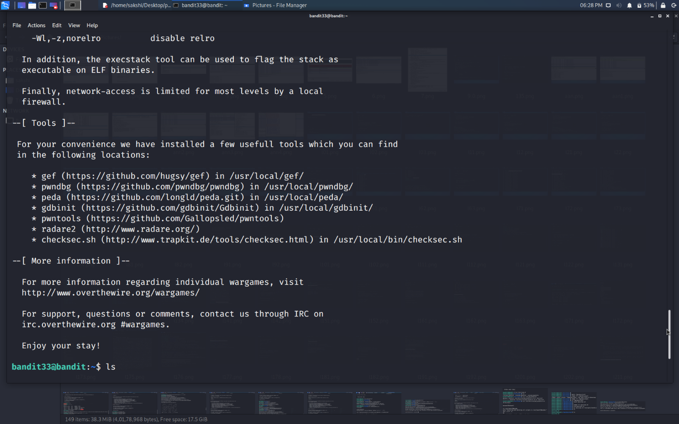

Successfully passed level 33.…